Mid-Year Meeting Minutes
10/20/2018 – 10/22/2018
- Welcome – Jason Fallon welcomed everyone and gave an overview of the weekend. Let’s use this weekend as a positive time to share ideas, come together, and troubleshoot problems
- Officer/Department Reports
  - President
    - Brian and Jason will be attending a conference called Connect. It’s goal is to help non-profits connect with CVCs across the country.
  - Vice President
  - Treasurer
    - Thanks to the sponsorship from Dallas we made $1000 last year. Without it, we would have lost money last year.

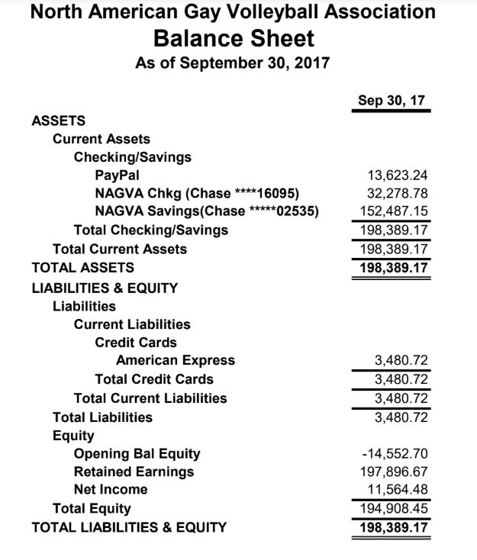
  - Secretary
  - Eligibility
    - June, 2017 - October, 2017
    - Medical Re-Rate: 22 received; 18 granted, 4 denied
    - 3 Year Inactive Re-Rate: 64 received; 61 granted, 3 denied
    - Grievances:
      - Championship Grievance
      - 8 Re-Rate Protests (all denied);
      - 2 Duplicate Profile
      - 1 Cheating
      - 1 Code of Conduct Violation
    - Question: Rich S – What would be grounds for overturning a rating. Answer: Eric N – Something wrong technically with the rating. Optics – an appeared conflict of interest.
    - Question: Mark D – Since adopting the 3 year inactivity rerate have you seen an increase in requests. Answer: Eric N – Huge increase.
  - Regions

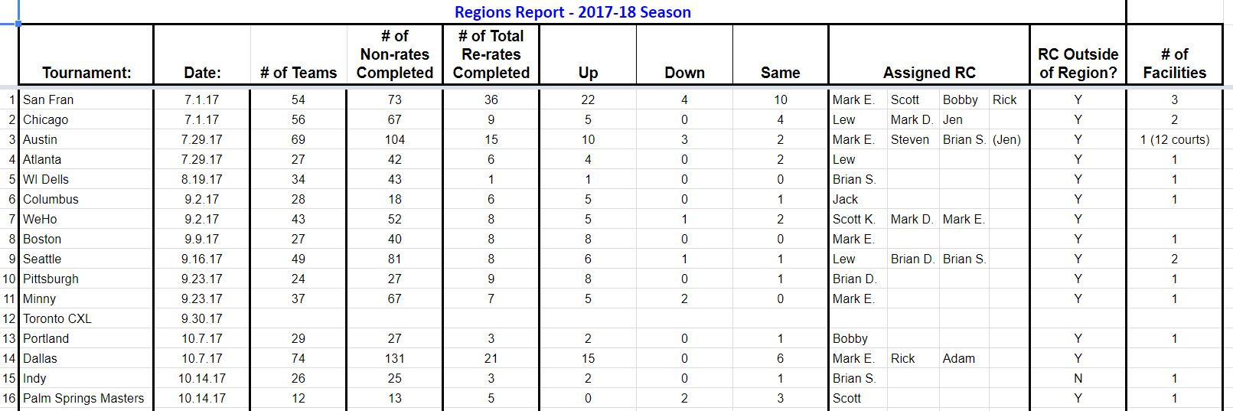
    - Question: Jen C: Sending more RCs to tournaments but are we charging tournaments more? Answer: No
    - Re-rate forms – Should we require the requestor to sign the form? Answer: double edge sword – fewer member driven requests but adds accountability
    - Q: What about asking for the requestor’s NAGVA number instead of name?
    - Q: Does it have to be the actual member requesting a downrate or can anyone put it in? Answer: Anyone.
  - Tournaments
    - Summer/Fall Season
      - 15 tournaments to date
      - Cancelled Toronto tournament
      - Added Atlanta to summer dates
      - Added Hawaii to Dec
      - Palm Springs back on the schedule after having to cancel last year
      - Attempted to distribute the September/Oct tournaments more evenly
    - Tournament Stats
      - Most tournaments are stable or rising
      - Dallas had 74 teams in one facility
        - Texas attendance rising after dropping from Championships surge
      - Boston dropped
        - Held A Division courts too long and couldn’t fill after cancelling
      - Nashville Rose
        - Did not attempt to hold the A division
      - Cancelled upper divisions in three tournaments – Boston, Indy, Pitt
    - Division Stats
      - B Division 220 registrations by 128 teams
      - BB division 254 registrations by 158 teams
    - Specific tournament problems or issues
      - Los Angeles
        - Communicating facility number
        - Added an additional RC one week before at significant cost
        - Large tournament with two registrations
        - Limited staffing for registration
        - Facility issues with AC and plumbing
        - Sent email detailing issues and received acceptable responses
    - Toronto
      - Cancelled their tournament with NAGVA due to low registrations and confirmed teams
      - Still held the tournament without NAGVA
    - Vegas
      - Facility cancellations
      - Third year this has happened for this tournament.
    - Puerto Rico
      - Cancelled due to hurricane
      - Attempting to run a tournament in Miami
      - Significant cost using convention center
      - Requires $2500 deposit
    - Long Beach
      - Low registrations possible cancellation
    - First set of rankings went out and will update after Louisville tournament
    - Will continue with the RC scouting reports
  - Officials
    - Created new R1 test
  - Registrar
    - Changed DOB requirement from 17 to 18 to avoid anymore problems
    - Adding certified refs and scorekeepers to line up forms
  - Webmaster
  - Communications
    - New Instagram account launched
    - Following our social media calendar for posts
    - Trying to keep things fun and informational
  - Canadian Representative
    - Talked to the heads of each league trying to create a Canadian NAGVA network.
    - Contacted each of the league heads and asked where does your organization fit with NAGVA.
    - Trying to figure out who’s playing, where are they playing, and why?
    - It’s all about the quality of play.
    - Registration fees: NAGVA dues in home currency
  - Getting added to Canadian league social media pages
- Members-At-Large Reports
  - Input about the NAGVA Board: Board members need to be more approachable
  - Upgrade officer’s page/job description
- Mission Statement Discussion
  - How do we implement it?
    - Inclusivity: more representation for the upper level players
    - Verbiage: Tranny…monitor social media for derogatory language
    - Create a safe space for people to complain about language they find offensive
    - Run clinics locally, mentor new tournaments, foster growth, offer scholarship
    - Fairplay: Ratings – keeping the talent level fair
    - Equality: Women’s nets or women’s division
    - Foreign language translations
    - Possible 5th division
    - More inclusion with Mexico and Canada
    - Latino Rep
    - Include more AA opportunities – ModA1
    - We accept everyone.
    - More discussion about transgender players
    - Outreach to the lesbian community
    - Give back to other communities other than Gay Men
    - Inclusivity: Access to the sport
    - Ask the local leagues what they do – women’s league? Master’s league?
    - We need to promote ourselves better
    - Celebrate individual excellence
    - Why do we run tournaments?
    - Celebrate the ally component more
    - Everyone plays component – player scholarship
    - Holding a party at a bar – doesn’t include the under 21 crowd
- New Business
  - Bids for Championships – Denver presented their bid. Jason A from Denver was present at the meeting to present and answer any questions
  - Championship Divisions and Fees
    - Divisions: Open, BB, B
    - Vote: Passed 14-0-1
    - Fees: 700/750/800 for 8 players
    - Vote: Unanimous
  - Championship’s Registration Launch Date – January 1st, 2018
  - NAGVA serves – We’ll be looking for a service project for Thursday in Minneapolis
  - Hall of Fame – 1st class this year. Committee is comprised of VP and MALs
  - MAL Special Projects – helping Registrar with missing DOBs
  - New Ref/Scorekeeper tests – waiting to hear back from Delawder
  - Fining tournaments
    - Discussion was held about amending Rules and Regs addressing facility fees
- Small Group Work
  - Skill Assessment form – Lew S, Jen C, Scott K, Jimmy S
    - Creating automatic point for serving
    - Separation of attacking points
    - Adding a front row only rating
  - Social Media effectiveness – Jason F, Andrew C, Jason P
    - “How Tos”
    - Highlight tournament directors
    - Youtube channel: Branded content, video of playing levels, walkthrough videos
  - Code of Conduct Revision – Mark E, Eric N, Mark D, Brian D
    - Updated language, removed redundancies, added anti-bullying language
    - Will present for approval at Championships
  - Hall of Fame – Brian C, Rich S, Brian S, Trevor B
    - Application will be ready by Dec 1
    - Still figuring out details for hall of fame inductees
- Meeting Adjourned

